 | 26.9.2 Editors - Properties Editor - Modifiers Properties Tab - Generate Modifiers
Table of content
Detailed table of content 1
Generate modifiers 10
Array Modifier 10
Bevel modifier 12
Boolean Modifier 18
Build Modifier 19
Dot Dash Modifier 20
Decimate Modifier 22
Edge Split Modifier 23
Geometry Modifier 24
Mask Modifier 25
Mirror modifier 25
Multiresolution Modifier 27
Remesh Modifier 30
Screw Modifier 31
Skin Modifier 32
Solidify modifier 34
Subdivision Surface modifier 38
Triangulate Modifier 39
Volume to mesh Modifier 40
Weld Modifier 41
Wireframe Modifier 42
Smooth Modifier 43
Mesh to Volume 46
Line Art Modifier 47
Vertex Weight Modifier 51

Detailed table of content

Detailed table of content
Detailed table of content 1
Generate modifiers 10
Array Modifier 11
Fit Type 11
Fixed Count 11
Fit Length 11
Fit Curve 11
Relative Offset 11
Factor X/Y/Z 11
Constant Offset 12
Distance X/Y/Z 12
Object Offset 12
Object 12
Merge 12
Distance 12
First and Last Copies 12
UV's 12
Offset U/V 12
Caps 12
Cap Start / End 12
Bevel modifier 12
Width Type 13
Offset 13
Width 13
Depth 13
Percent 13
Absolute 13
Amount 13
Segments 13
Affect 13
Edges 13
Vertices 13
Limit Method 13
None 14
Angle 14
Angle 14
Weight 14
Vertex Group 14
Vertex Group 14
Invert 14
Profile 14
Super Ellipse 14
Shape 14
Custom 15
Miter Shape 15
Custom Profile 15
Preset 15
Zoom in 15
Zoom out 15
Tools 15
Reset View 15
Reset Curve 15
Reverse Path 15
Toggle Profile Clipping 15
Curve view 15
Handle Type Auto Handle 16
Handle Type Vector Handle 16
Handle Type Free Handle 16
Handle Type Aligned Free Handle 16
X Y Values 16
Delete 16
Sample Straight Edges 16
Sample Even Lengths 16
Geometry 16
Miter Inner 16
Sharp 16
Arc 16
Outer 17
Sharp 17
Patch 17
Arc 17
Intersections 17
Clamp Overlap 17
Loop Slide 17
Shading 17
Harden Normals 17
Mark 18
Seam 18
Sharp 18
Material Index 18
Face Strength 18
None 18
New 18
Affected 18
All 18
Boolean Modifier 18
Operation 19
Intersect 19
Union 19
Difference 19
Operand Type 19
Object 19
Solver 20
Overlap Threshold 20
Build Modifier 20
Start 20
Length 20
Reversed 20
Randomize 20
Seed 20
Dot Dash Modifier 20
Offset 20
Segment list 21
Add Segment 21
Remove Segment 21
Move Dash Segment up or down 21
Search element 21
Edit Box 21
Invert 21
Sort by name 21
Reverse 21
Dash 21
Gap 21
Radius 21
Opacity 21
Material Index 22
Influence 22
Layer 22
Inverse Layers 22
Pass 22
Inverse Pass 22
Material 22
Invert Materials 22
Pass 22
Inverse Pass 22
Decimate Modifier 22
Mode 22
Collapse 22
Ratio 23
Symmetry 23
Triangulate 23
Vertex Group 23
Invert 23
Un-Subdivide 23
Iterations 23
Planar 23
Angle Limit 23
Delimit 23
Normal 23
Material 23
Seam 24
All Boundaries 24
Face Count 24
Edge Split Modifier 24
Edge Angle 24
Sharp Edges 24
Geometry Modifier 24
Data Browser 25
Edit box 25
Add Fake User 25
User 25
Add 25
Remove 25
Mask Modifier 25
Mode 25
Vertex Group 25
Armature 25
Invert 26
Threshold 26
Mirror modifier 26
Workflow 26
Axis 26
Bisect 26
Flip 26
Mirror Object 26
Clipping 26
Merge 27
Bisect Distance 27
Merge Distance 27
Data 27
Mirror UV 27
Vertex Groups 27
Flip UDIM 27
Multiresolution Modifier 27
Workflow 28
Level Viewport 28
Sculpt 28
Render 28
Sculpt at Base Mesh 28
Optimal Display 28
Subdivision Subpanel 28
Subdivision Mode 28
Subdivide 28
Simple 28
Linear 28
Unsubdivide 29
Delete Higher 29
Shape subpanel 29
Reshape 29
Apply Base 29
Generate Subpanel 29
Save External / Pack External 29
File path 29
Type 29
Catmull-Clark 29
Simple 29
Levels Sculpt 29
Viewport 30
Render 30
Advanced Subpanel 30
Quality 30
UV Smooth 30
Smooth, keep corners 30
Sharp 30
Use Creases 30
Remesh Modifier 30
Blocks, Smooth, Sharp 30
Octree Depth 30
Scale 31
Sharpness 31
Remove Disconnected 31
Threshold 31
Smooth Shading 31
Voxel 31
Voxel Size 31
Adaptivity 31
Smooth Shading 31
Screw Modifier 31
Angle 31
Screw 32
Iterations 32
Axis 32
Screw 32
Axis Object 32
Object Screw 32
Steps Viewport 32
Render 32
Merge 32
Merge Distance 32
Stretch UV's 32
Normals 32
Smooth Shading 32
Calculate Order 32
Flip 33
Skin Modifier 33
Branch Smoothing 33
Symmetry Axes X/Y/Z 33
Smooth Shading 33
Create Armature 34
Add Skin Data 34
Mark / Clear Loose 34
Mark Root 34
Equalize Radii 34
Solidify modifier 34
Mode 35
Simple 35
Thickness 35
Offset 35
Even Thickness 35
Rim 35
Fill 35
Only Rim 35
Complex 35
Thickness Mode 36
Fixed 36
Even 36
Constraints 36
Boundary 36
None 36
Round 36
Flat 36
Thickness 36
Offset 36
Merge Threshold 36
Rim 36
Fill 36
Only Rim 37
Vertex Group 37
Invert 37
Factor 37
Flat Faces 37
Normals 37
Flip Normals 37
High Quality Normals 37
Materials 37
Material Offset 37
Rim 37
Edge Data 38
Inner 38
Outer 38
Rim 38
Bevel Convex 38
Thickness Clamp 38
Clamp 38
Angle Clamp 38
Output Vertex Groups 38
Shell 38
Rim 38
Subdivision Surface modifier 38
Type 38
Catmull-Clark 38
Simple 39
Levels Viewport 39
Render 39
Optimal Display 39
Advanced 39
Quality 39
UV Smooth 39
Smooth, keep corners 39
Sharp 39
Use Creases 39
Triangulate Modifier 40
Quad Method 40
Beauty 40
Fixed 40
Fixed Alternate 40
Shortest Diagonal 40
Polygon Method 40
Beauty 40
Clip 40
Minimum Vertices 40
Keep Normals 40
Volume to mesh Modifier 40
Object 41
Grid Name 41
Resolution Mode 41
Grid 41
Voxel Amount 41
Voxel Size 41
Threshold 41
Adaptivity 41
Smooth Shading 41
Weld Modifier 41
Mode 42
All 42
Connected 42
Distance 42
Only Loose Edges 42
Vertex Group 42
Invert 42
Wireframe Modifier 42
Thickness 42
Offset 42
Boundary 42
Replace Original 42
Thickness 43
Even 43
Relative 43
Crease Edges 43
Crease Weight 43
Material Offset 43
Vertex Group 43
Invert 43
Factor 43
Smooth Modifier 43
Affect 43
Position 44
Strength 44
Thickness 44
UV 44
Factor 44
Repeat 44
Influence 44
Layer 44
Invert 44
Pass 44
Invert 44
Material 44
Invert 44
Pass 45
Invert 45
Vertex Group 45
Invert 45
Custom Curve 45
Navigation elements 45
Zoom in and out 45
Tools 45
Reset View 45
Vector Handle 45
Auto Handle 45
Auto Clamped Handle 45
Extend Horizontal 46
Extend Vertical 46
Reset Curve 46
Use Clipping 46
Delete Points 46
Curve window 46
X / Y 46
Mesh to Volume 46
Object 46
Density 46
Fill Volume 47
Exterior Band Width 47
Interior Band Width 47
Resolution Mode 47
Voxel Amount 47
Voxel Size 47
Line Art Modifier 47
Source Type 47
Collection 47
Source Collection 48
Object 48
Source Collection 48
Scene 48
Target Layer 48
Target Material 48
Edge Types Subpanel 48
Crease Threshold 48
Allow Overlap 48
Geometry Processing Subpanel 48
Remove Doubles 48
Overlapping Edges as Contour 48
Instanced Objects 49
Clipping Boundaries 49
Style subpanel 49
Thickness 49
Opacity 49
Occlusion subpanel 49
Range 49
Level 49
Level Start / Level End 49
Material Masks 49
Masks 49
Match all masks 49
Intersections subpanel 49
Masks 49
Match all masks 50
Face Mask Filtering subpanel 50
Invert 50
Boundaries 50
Chaining Subpanel 50
Chain 50
Intersection With Contour 50
All Lines 50
Image Threshold 50
Angle Splitting 50
Vertex Weight Transfer 50
Filter Source 50
Match Output 51
Target 51
Baking 51
Bake Line Art 51
Bake Line Art ( All ) 51
Clear Baked Line Art 51
Clear Baked Line Art ( All ) 51
Vertex Weight Modifier 51
Mode 51
Distance 51
Output 51
Minimum 52
Invert 52
Blend 52
Object 52
Distance Start 52
Distance End 52
Angle 52
Output 52
Minimum 52
Invert 52
Blend 52
Angle 52
Axis 52
Space 53
Influence subpanel 53
Layer 53
Invert 53
Pass 53
Invert 53
Material 53
Invert 53
Pass 53
Invert 53
Vertex Group 53
Invert 53

Generate modifiers

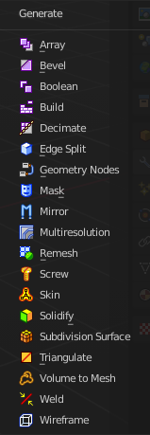
Some of the modifiers are just available for specific object types.
Left grease pencil object, right a mesh object.

Array Modifier
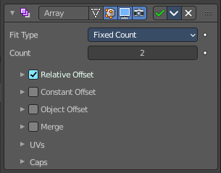
The Array modifier creates an array of copies of the base object. Each copy can offset from the previous one in any of a number of possible ways. Vertices in adjacent copies can be merged if they are nearby, allowing smooth Subdivision Surface frameworks to be generated.
This modifier can be useful when combined with tillable meshes for quickly developing large scenes. It is also useful for creating complex repetitive shapes.
Multiple Array modifiers may be active for an object at the same time. This allows to create complex three-dimensional constructs.
Hint for Offset Calculation. The transformation applied from one copy to the next is calculated as the sum of the three different components (Relative, Constant and Object), each of which can be enabled/disabled independently of the others. This allows, for example, a relative offset of (1.0, 0.0, 0.0) and a constant offset of (0.1, 0.0, 0.0), giving an array of objects neatly spaced along the X axis with a constant 0.1 unit between them, whatever the original object’s size.

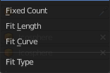
Fit Type
Controls how the length of the array is determined.

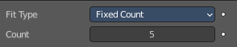
Fixed Count
Generates the number of copies specified in Count.

Fit Length
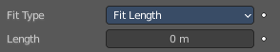
Generates copies to fit within the fixed length given by Length.

Fit Curve
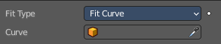
Generates copies to fit within the length of the curve object specified in Curve. You need to select a curve object.

Note! Both Fit Curve and Fit Length use the local coordinate system size of the base object, which means that scaling the base object in Object Mode will not change the number of copies generated by the modifier.

Fit Length uses the local coordinate system length of the curve, which means that scaling the curve in Object Mode will not change the number of copies generated by the modifier.

Applying the scale can be useful for both.

Relative Offset

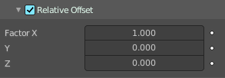
Factor X/Y/Z
Adds a translation equal to the object’s bounding box size along each axis to the offset, multiplied by a scaling factor. X, Y and Z scaling factors can be specified.

Constant Offset

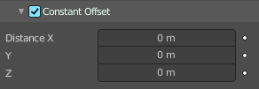
Distance X/Y/Z
Adds a constant translation component to the duplicate object’s offset. X, Y and Z constant components can be specified.

Object Offset
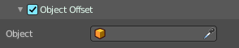
Adds a transformation taken from a chosen object relative to the current object to the offset.

Object
Choose an object.

Merge
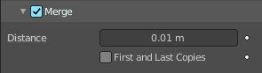
If enabled, vertices in each copy will be merged with vertices in the next copy that are within the given Distance.

Distance
The merge distance between the vertices. Vertices below this distance will be merged.

First and Last Copies
Merge vertices in first and last duplicates.

UV's

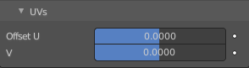
Offset U/V
Shifts UV's of each new duplicate by a settable amount.

Caps

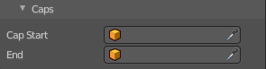
Cap Start / End
Adds a chosen mesh at the start and end of the array. The start object is added at position -1. The end object at position +1. When Merge is activated, and the cap vertices are within the Distance threshold, they will be merged.

Note! The start/end cap objects currently do not support the First and Last Copies option.

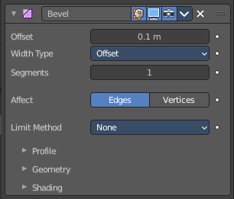
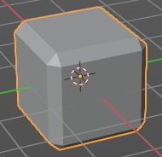
Bevel modifier
The Bevel modifier bevels the edges of the mesh. It is a non-destructive alternative to the Bevel Operation in Edit Mode.

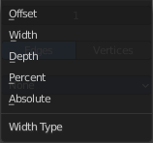
Width Type
Defines how Width will be interpreted to determine the amount of bevel.

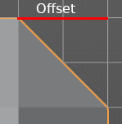
Offset
Value is interpreted as the distance from the original edge to the edge of the beveled face.

Width
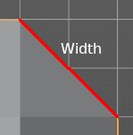
Value is interpreted as the distance between the two new edges formed by the bevel.

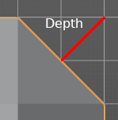
Depth
Value is the perpendicular distance from the new bevel face to original edge.

Percent
Similar to Offset but the value is interpreted as a percentage of the adjacent edge length.

Absolute
Amount is absolute along adjacent edge.

Amount
The bevel amount.

Segments
The number of edge loops added along the bevel’s face.

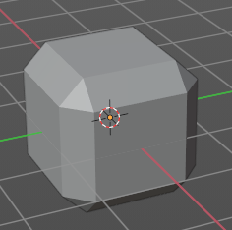
Affect

Edges
Bevels both edges and vertices.

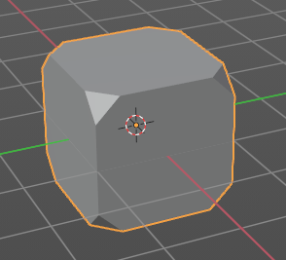
Vertices
Only the areas near vertices are beveled, the edges remain unchanged.

Limit Method
Used to control where a bevel is applied to the mesh.

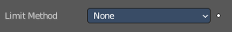
None
No limit, all edges will be beveled.

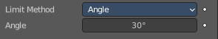
Angle
Only edges where the adjacent faces form an angle smaller than the defined threshold will be beveled. Intended to allow you to bevel only the sharp edges of an object without affecting its smooth surfaces.

Angle
The angle above which to bevel.


Weight
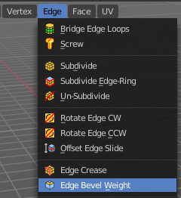
Use each edge’s bevel weight to determine the width of the bevel. When the bevel weight is 0.0, no bevel is applied.

Edge bevel weight can be set in Edit mode in the Edge menu with the Edge Bevel Weight tool.

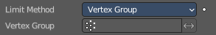
Vertex Group
Use weights from a vertex group to determine the width of the bevel. When the vertex weight is 0.0, no bevel is applied. An edge is only beveled if both of its vertices are in the vertex group. See here about adjusting vertex group weights.

Vertex Group
Choose the vertex group.

Invert
Inverts the influence of the selected vertex group.

Profile
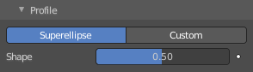
The profile defines the shape of the bevel. Profile has no effect if the number of segments is below 2.

Super Ellipse
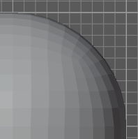
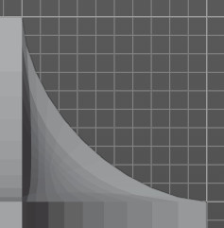
Defines a rounded bevel corner.

Shape
The shape of the rounded bevel corner. A value close to 0 bends the roundness to inside. A value towards 1 bends the curve to outside. A value of 0.5 defines a radius around the center point of the bevel.

Custom
Here you can define a custom shape profile for the bevel.

Miter Shape
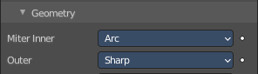
The shape of the custom bevel corner. Has no effect when the miter type is sharp. You need to set it to Arc in the geometry section.

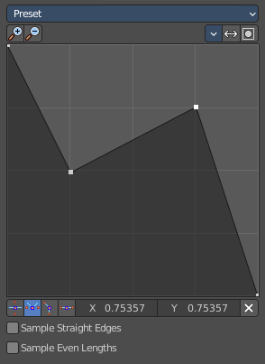
Custom Profile
Choose and adjust a custom bevel profile. This feature needs more than one segment to work.

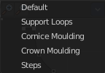
Preset
Choose some profile presets.

Zoom in
Zooms into the curve view.

Zoom out
Zooms out of the curve view.

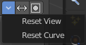
Tools

Reset View
Resets the zoom factor of the curve view.

Reset Curve
Resets the curve to the defaults. This means when you choose a curve preset to reset it to the values of the latest chosen preset.

Reverse Path
The path gets reversed. The first point becomes the last and vice versa.

Toggle Profile Clipping
Toggles the profile clipping.

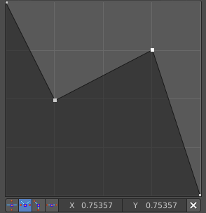
Curve view
Adjust the profile curve.
Left click where no point is adds a new point. Left click at a point allows you to move it.
Holding down Shift while moving a node point activates precision movement.
Holding down ctrl while moving activates temporary snapping.
When a point is selected then the curve view reveals a sub menu at the bottom.

Handle Type Auto Handle
Sets the handle type of this curve point to smooth.

Handle Type Vector Handle
Sets the handle type of this curve point to sharp.

Handle Type Free Handle
Sets the handle type of this curve to Free handles. The curve point has now two handles with which you can adjust the curve before and after the point each.

Handle Type Aligned Free Handle
Sets the handle type of this curve to Free handles. The curve point has now a handle with which you can adjust the curve.

X Y Values
The position of the currently selected curve point.

Delete
Delete the selected curve point.

Sample Straight Edges
Sample edges with vector handles.

Sample Even Lengths
Sample edges with even lengths.

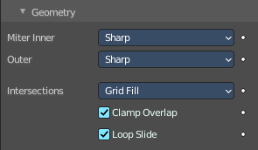
Geometry

Miter Inner
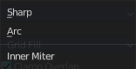
How the inner miter is set. Miter is how the bevel rounding at a corner is done.


Sharp
Creates a sharp miter.

Arc

This replaces the vertex of a miter with 2 vertices, joined by an arc. A separate Spread parameter says how far to move the vertices away from their original position.

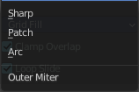
Outer
How the outer miter is set. Miter is how the bevel rounding at a corner is done.

Sharp
Creates a sharp miter.


Patch
This replaces the outside vertex of a miter with 3 vertices. And uses a patch pattern there.

Arc
This replaces the vertex of a miter with 2 vertices, joined by an arc. A separate Spread parameter says how far to move the vertices away from their original position.

Intersections
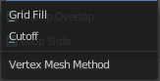
If a bevel corner is filled or not. Needs minimum two segments to have effect.
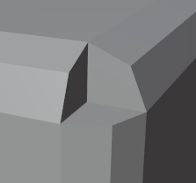
When the inner corners of the cutoff profiles faces meet at the same location with a three way intersection, then no center face is created.
The direction of the cutoff faces depends on the original vertex’s normal.

Clamp Overlap
Limits the width of each beveled edge so that edges cannot cause overlapping intersections with other geometry.

Loop Slide
If there are unbeveled edges along with beveled edges into a vertex, the bevel tries to slide along those edges when possible. Turning the option off can lead to more even bevel widths.

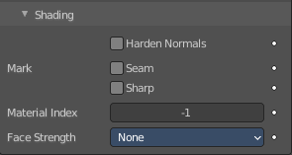
Shading

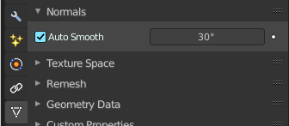
Harden Normals
Match normals of new faces to adjacent faces.
Autosmooth needs to be enabled for this feature. And the shading needs to be smooth.

Mark

Seam
When the beveled edge is a seam edge, then the bevel will also contain a seam to keep the seam into account.

Sharp
When the beveled edge is a sharp edge, then the bevel will also contain a sharp edge to keep the sharp edge into account.

Material Index
The index of the material slot to use for the bevel. When set to -1, the material of the nearest original face will be used.

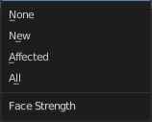
Face Strength
Set the Face Strength on the faces involved in the bevel by the mode specified here.
This face strength then can be used in conjunction with a following Weighted Normals modifier (with the Face Influence option checked).

None
Do not set face strength.

New
Set the face strength of new faces along edges to Medium, and the face strength of new faces at vertices to Weak.

Affected
In addition to those set for the New case, also set the faces adjacent to new faces to have strength Strong.

All
In addition to those set for the Affected case, also set all the rest of the faces of the model to have strength Strong.

Boolean Modifier
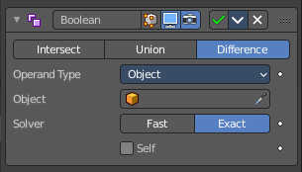
The Boolean modifier uses one of the three available Boolean operations to create a single mesh out of two mesh objects. Union, Difference and Intersect. This modifier needs a second object to be the target of the operation.
Boolean operations may or may not deliver useful results. And requires nearly always manual cleanup afterwards since it tends to create N-Gon geometry and can create micro triangles. You should also avoid co-planar faces. Manifold meshes works best.
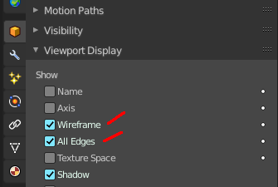
Tip! Tick Wireframe, and All Edges in the Viewport Display panel to see the bool result in realtime happen. And hide the bool object. That way you can tweak the positions of the objects if needed.

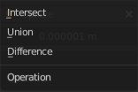
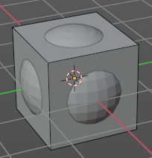
Operation
The Boolean operation to use.
Demonstrated at a cube with the modifier applied, and a sphere as the target object.

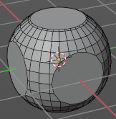
Intersect
Keeps the intersecting geometry, removes the non intersecting geometry.

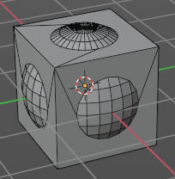
Union
The target mesh is added to the modified mesh.

Difference
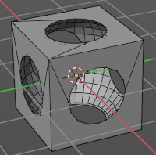
Keeps the non intersecting geometry, removes the intersecting geometry.

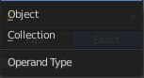
Operand Type

Object
The target mesh object. You need to choose a target mesh object for the boolean operation.

Solver
Fast or Exact.

Overlap Threshold
The threshold for overlapping geometry. This value determines above which value a boolean operation happens.

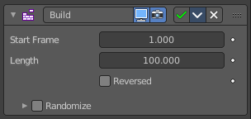
Build Modifier
The Build modifier lets the faces of the mesh object to appear or disappear one after the other over time when you play the animation.

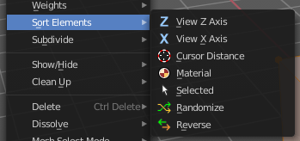
By default, faces appear in the order in which they are stored in memory, which follows the order how they are created. This face/vertex order can be altered in Edit Mode by using Sort Mesh Elements in the Mesh menu.

Start
The start frame of the building process.

Length
The number of frames over which to rebuild the object.

Reversed
The modifier will operate in reverse, and start with the full mesh. And deconstruct it towards the end frame.

Randomize
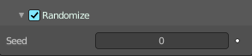
Randomizes the order in which the faces are built.

Seed
The random seed. Changing this value gives a different “random” order when Randomize is checked. This order is always the same for a given seed/mesh set.

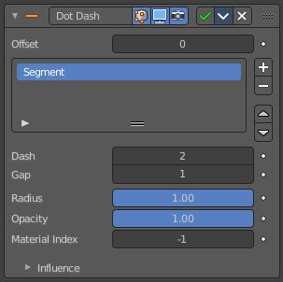
Dot Dash Modifier
Grease Pencil only. Turns a grease pencil stroke into a dotted line.

Offset
The offset into each stroke before the dot creation starts.

Segment list
Manage the single segments of the dotted dash. Segments gets repeated as they appear in the list. Means when you just have one segment in the list, then this shape will be repeated. When you have two, then the first will be displayed, then the second, then the first, and so on. Every segment can have its own settings. Which are managed below.

Add Segment
Add a new dash segment.

Remove Segment
Remove the dash segment.

Move Dash Segment up or down
Moves the selected dash segment up or down in the list.

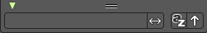
Search element
By clicking at the triangle button you reveal a search field with which you can search through the list.

Edit Box
Type in the search term and hit enter.

Invert
Inverts the search term.

Sort by name
Sorts the list alphabetically.

Reverse
Inverts the list.

Dash
The number of points (vertices) from the orignal stroke to include in this segment.

Gap
The number of points (vertices) skipped after this segment.

Radius
The radius of the segment. Maximum is 1 of the original stroke.

Opacity
The visibility of this segment.

Material Index
What material to use.

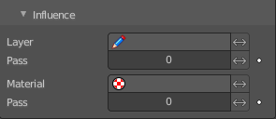
Influence

Layer
Restricts the effect only to one layer or to any layers that share the same pass index. Click to pick the layer that you want to use.

Inverse Layers
Inverts the influence.

Pass
The layer pass index.

Inverse Pass
Inverts the influence.

Material
Restricts the effect only to material that share the same material or pass index. Click to pick the material that you want to use.

Invert Materials
Inverts the influence.

Pass
The material pass index.

Inverse Pass
Inverts the influence.

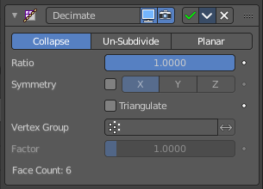
Decimate Modifier
The Decimate modifier allows you to reduce the vertex/face count of a mesh with minimal shape changes. The result is just displayed in Object mode. In Edit mode the unaltered mesh is shown.

Mode

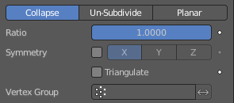
Collapse
This algorithm uses progressive merging of vertices, taking the shape of the mesh into account.

Ratio
The ratio of faces to keep after decimation. 1.0 is not altered. The lower the value the stronger the reduction.
Note! Although the Ratio is directly proportional to the number of remaining faces, triangles are used when calculating the ratio.
This means that if your mesh contains quads or other polygons, the number of remaining faces will be larger than expected, because those will remain unchanged if their edges are not collapsed.
This is only true if the Triangulate option is disabled.

Symmetry
Maintains symmetry on a single axis.

Triangulate
Keeps any resulting triangulated geometry from the decimation process.

Vertex Group
A vertex group that controls what parts of the mesh are decimated.

Invert
Decimate the geometry except the vertex group.

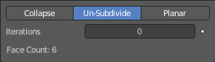
Un-Subdivide
This algorithm tries to unsubdivide divided faces.

Iterations
The number of times to perform the unsubdivide operation. Two iterations is the same as one subdivide operation, so you will usually want to use even numbers.

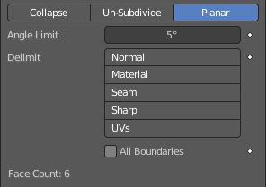
Planar
This algorithm reduces details by unioning adjacent faces that are below an angle limit.

Angle Limit
Dissolve geometry which form angles (between surfaces) higher than this setting.

Delimit
Prevent dissolving geometry in certain places.

Normal
Does not dissolve edges on the borders of areas where the face normals are reversed.

Material
Does not dissolve edges on the borders of where different materials are assigned.

Seam
Does not dissolve edges marked as seams.

All Boundaries
When enabled, all vertices along the boundaries of faces are dissolved.

Face Count
The face count of the decimated mesh.

Edge Split Modifier
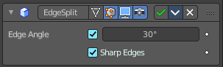
The Edge Split modifier splits single edges into two independent edges when the adjacent faces are below the defined angle. Or when the edge is marked as sharp. Which can be done in edit mode in the Edge menu with the Mark Sharp tool.
Splitting an edge affects vertex normal generation at that edge, and makes the edge appear sharp. So this modifier can be used to achieve the same effect as Auto Smooth. And make edges appear sharp when their angle is above a certain threshold. It can also be used for manual control of the smoothing process, where the user defines which edges should appear smooth or sharp (see Mesh Smoothing for other ways to do this). If desired, both modes can be active at once.
Note! This modifier is kept mostly for historical/compatibility reasons. Everything it can do in shading, and much more, can now be achieved using custom normals. Unless you really need the topology changes it generates, it is not advised to use it in new projects.

Edge Angle
The angle above which to split edges.

Sharp Edges
When you have marked edges as sharp, then these edges will be split.
Note! Non-manifold edges will always be split.

Geometry Modifier
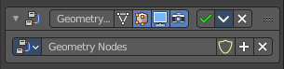
The geometry modifier adds a geometry node tree, which can be modified in the geometry node editor.

Manage the nodes. If there is no geometry node tree for the current object, then you will see the New button

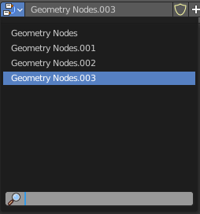
Data Browser
The list of available geometry node trees in the scene.

Edit box
The name of the current active geometry node tree. Here you can also rename the node tree.

Add Fake User
Wit this button you assign a fake user to this selected geometry node tree.
Data, like node trees, that is not longer linked to anything else gets removed when you save and reload a scene. Bforartists has the concept of fake users to go around this behavior. An image with a fake user is in fact linked to something. And so it is not lost when you save and reload the scene.

User
The number of users that uses this data. Data with a user number of 0 will be removed with closing Bforartists.

Add
Add a geometry node.

Remove
Removes the geometry node tree. To delete it completely you need to purge it. See Fake user.

Mask Modifier
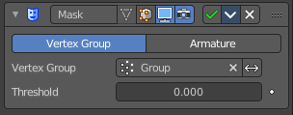
The Mask modifier allows to hide vertices of an object dynamically based on vertex groups or an Armature.

Mode
Use Vertex Groups or an armature to hide the mesh Vertex Group works in Object mode. Armature works in Pose mode, and uses the active bone for masking.

Vertex Group
Here you can select the vertex group that you want to use for masking. The geometry from this vertex group is shown.

Armature
When in Pose Mode, vertices belonging to the vertex group associated with the active bone (same names) will be visible. Vertices not in that group will be hidden.

Invert
Show the not selected geometry instead of the selected.

Threshold
Vertices with weights less or equal to this value will be hidden.

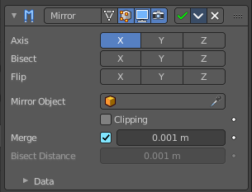
Mirror modifier
The Mirror modifier mirrors a mesh along its local X, Y and/or Z axes, across the Object Origin. It can also use another object as the mirror center, then use that object’s local axes instead of its own.

Workflow
Usually this modifier is used for mirror modeling in edit mode. In Edit mode just the original side is editable then. Recommend is to remove half of the mesh before starting. The missing part will then be added by the Mirror modifier. But you can also use the Bisect feature.

Axis
The axis to mirror along.
You can select more than one of these axes. And will then get more mirrored copies. With one axis you get a single mirror, with two axes four mirrors, and with all three axes eight mirrors.

Bisect
If the mesh is already on both sides of the mirror plane, it is cut by that plane. And only one side (the “negative” one by default) is kept to perform the mirror process.
Note. When you turn Bisect on and pull at the mirror part, then you won't have the mirroring effect to the original side.

Flip
When Bisect is enabled on an axis, you can use this setting to switch the side kept and mirrored (i.e. when it is enabled, the “positive” side will be kept, instead of the “negative” one).

Mirror Object
An Object Selector to select an object (usually an empty), which position and rotation will be used to define mirror planes (instead of using the ones from the modified object).
You can animate it to move the mirror axis.

Clipping
Prevents vertices from moving through the mirror plane(s) when you transform them in Edit Mode.
If it is enabled but vertices are beyond the mirror plane and outside of the Merge Distance, the vertices will not be merged. But as soon as the vertices are within Merge Distance they are snapped together and cannot be moved beyond the mirror plane.
Note! Vertices on the mirror plane will be unable to move away from the mirror plane as long as Clipping is enabled. You must disable it to be able to move the vertices along the mirror axis again.

Merge
Where a vertex is in the same place (within the Merge Distance) as its mirror it will be merged with the mirrored vertex.

Bisect Distance
Vertices are removed up to this distance from the bisect plane.

Merge Distance
The maximum distance between a vertex and its mirror copy at which they are merged together (being snapped on the mirror plane). Needs Merge to be enabled.

Data

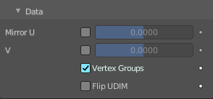
Mirror UV
Mirror the UV texture coordinates across the middle of the image.

Vertex Groups
Try to mirror existing vertex groups.
Note! The vertex groups you want to mirror must be named following the usual left/right pattern (i.e. with suffixes like “.R”, “.right”, “.L”, etc.). The mirror side vertex group must already exist (it will not be created automatically). It must also be completely empty (no vertices assigned to it).

Flip UDIM
Mirror the texture coordinates around each tile center.

Multiresolution Modifier
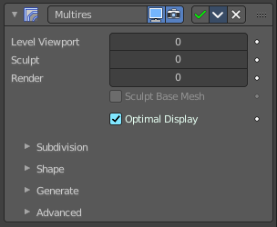
The Multiresolution modifier, in short “Multires”) allows you to subdivide a mesh similarly to the Subdivision Surface modifier, but also allows you to edit the new subdivision levels in Sculpt Mode.
Note! Multiresolution cannot be re-positioned in the stack after any modifier that will change geometry or other object data (This means all Generate, some Modify and some Simulate modifiers cannot come before the Multiresolution modifier). It needs to work at the unaltered base mesh.

Workflow
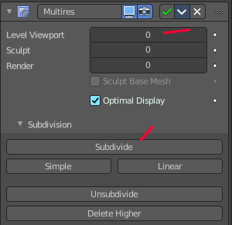
Add the modifier. Switch to Sculpt mode. Click at the Subdivide button. The Levels sculpt slider will now turn to 1. Do some sculpting. Click at the Subdivide button again. The Levels sculpt slider will now turn to 2. You have added a second sds layer now. Do some sculpt now. Click at the Subdivide button again, and you have a third sds sculpting level. Do some sculpt now.
To work at level 1 SDS simply change the Levels sculpt value back to 1. Or to 2 when you want to work at layer 2.

Level Viewport
Number of subdivisions in the viewport when not in sculpt mode.

Sculpt
Number of subdivisions to use in sculpt mode.

Render
Number of subdivisions when rendering the image.

Sculpt at Base Mesh
Sculpt at the base mesh, not at the multires sds layer.

Optimal Display
In object mode the subdivided edges will not be drawn. Only the edges of the base geometry.

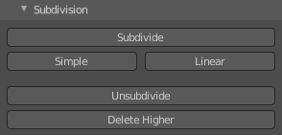
Subdivision Subpanel

Subdivision Mode

Subdivide
Adds another layer of subdivision. This subivision method divides the mesh smooth with the catmull clark algorithm.

Simple
Adds another layer of subdivision. The simple method just divides the existing faces.

Linear
Adds another layer of subdivision. The linear method divides the existing faces and interpolates linear.

Unsubdivide
Removes all subdivision layers.

Delete Higher
Removes the highest subdivision layer.

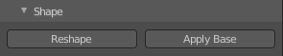
Shape subpanel

Reshape
Copies vertex coordinates from another mesh.
Usage: first select a different mesh object with matching topology and vertex indices. Shift select the object you wish to copy vertex coordinates to. Click Reshape.

Apply Base
Modifies the original unsubdivided mesh to match the form of the subdivided sculpted mesh.

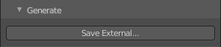
Generate Subpanel

Save External / Pack External
Saves displacements to an external .btx file. The Multiresolution sds information is then stored externally, so that the blend files doesn't become too big.

File path
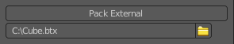
Once saved you will see the path to the btx file below the save external button. The save external button has turned into Pack external then.

Type
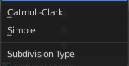
Sets the type of subdivision. Note! You need to set the subdivision type before you start. You can't change it afterwards.

Catmull-Clark
Creates a smoothed surface, using the standard Catmull-Clark subdivision surface algorithm.

Simple
Maintains the current shape, and simply subdivides edges.

Levels Sculpt
The subdivision layer.

Viewport
Set the level of subdivisions to show in Object Mode. In Sculpt mode this value has no effect.

Render
Set the level of subdivisions to show when rendering.

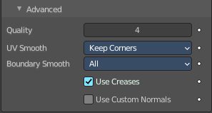
Advanced Subpanel

Quality
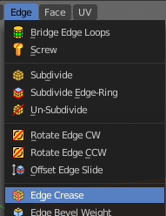
How precisely the vertices are positioned. This settings becomes active when you have an edge crease applied. This can be done in edit mode in the edge menu.

UV Smooth
How to handle UV's during subdivision.

Smooth, keep corners
UV islands are smoothed, but their boundary remain sharp.

Sharp
UV remain unchanged.

Use Creases
Use the crease information. This settings becomes active when you have an edge crease applied.

Remesh Modifier
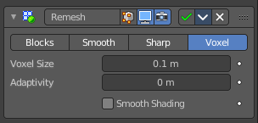
The Remesh modifier generates new mesh topology. The output follows the surface curvature of the input. But its topology contains quads.
The output and also the settings of the three basic modes Blocks, Smooth and Sharp is almost identical. Except the smoothing.

Blocks, Smooth, Sharp
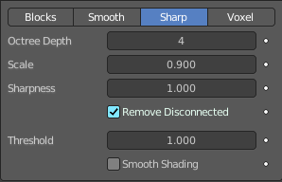
Blocks has no smoothing at all. Smooth outputs a smooth surface. Sharp outputs a smooth surface but preserves sharp edges and corners.

Octree Depth
The resolution of the Octree. Higher values gives finer details.

Scale
The ratio of the largest dimension of the model over the size of the grid.

Sharpness
Sharp mode only. Tolerance for outliers. Higher values produce edges more similar to the input, while lower values filter out noise.

Remove Disconnected
Filter out small disconnected pieces of the output.

Threshold
Use this to control how small a disconnected component must be to be removed.

Smooth Shading
Output faces with smooth shading. The smooth/flat shading of the input faces is not preserved.

Voxel
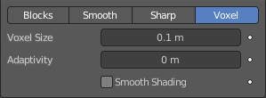
Generate a new manifold mesh from the current geometry while trying to preserve the mesh’s original volume.

Voxel Size
The voxel size. Defines the resolution of the created mesh.

Adaptivity
Reduces the final face count by simplifying geometry where detail is not needed. This feature triangulates faces that do not need as much detail.

Smooth Shading
Output faces with smooth shading. The smooth/flat shading of the input faces is not preserved.

Screw Modifier
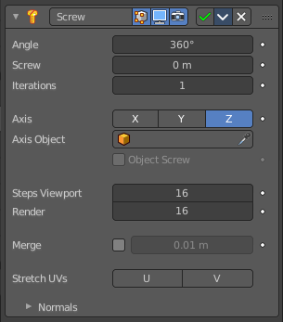
The Screw modifier takes a profile object, a mesh or a curve, to create a helix-like shape.
The profile should be properly aligned to the cardinal direction of the object.

Angle
Degrees for a single helix iteration.

Screw
Offsets the iteration along its axis.

Iterations
Number of iterations.

Axis
The axis along which the helix will be built.

Screw
The height of one helix iteration.

Axis Object
Pick an object to define the axis direction. The helix will then point into the direction of this object.

Object Screw
Use the distance from the Axis Object to define the height of one helix iteration.

Steps Viewport
Number of steps used for a single revolution displayed in the 3D Viewport.

Render
Number of steps used for a single revolution used during render time. Higher values gives higher quality.

Merge
Merge vertices that lie on the axis of rotation. Closes off end points with a triangle fan.

Merge Distance
Vertices under this distance to the axis are merged.

Stretch UV's
Stretch the UV coordinates from (0.0 to 1.0) when UV's are present.

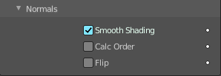
Normals

Smooth Shading
Output faces with smooth shading. The smooth/flat shading of the input geometry is not preserved.

Calculate Order
Order of edges is calculated to avoid problems with normals and shading. Only needed for meshes, not curves.

Flip
Flip normals direction.

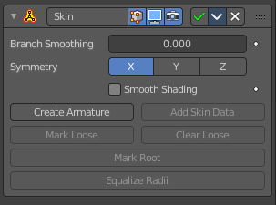
Skin Modifier
The Skin modifier uses vertices and edges to create a skinned surface. The output is mostly quads. But intersections can also produce triangles.
You can use geometry with faces as the base geometry. But the modifier just uses the vertices and edges information.

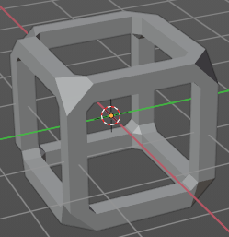
Note! Faces in the original geometry are ignored. The modifier works with the edges and vertices of the geometry. The faces of a cube for example gets removed. The new geometry appears around the edges.

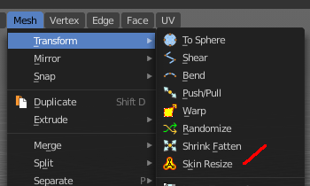
Note! The thickness of the created geometry can be adjusted in Edit mode with the Skin Resize tool.

Note! The Edit mode also activates most of the in Object mode greyed out tools.

Branch Smoothing
A branch point is a vertex with three or more connected edges. These areas tend to produce more complicated topology, some of which may overlap. This setting relaxes the surface around these points, with the side effect of shrinking it.

Symmetry Axes X/Y/Z
Keep the output topology symmetrical in their here chosen axes.
Note! They do not add geometry flipped across an axis. For that, the Mirror modifier should be used, typically placed above the Skin modifier.

Smooth Shading
Output faces with smooth shading rather than flat shading. The smooth/flat shading of the input geometry is not preserved.

Create Armature
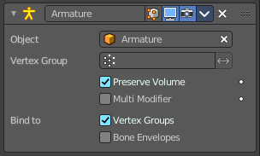
Creates an armature modifier below the Skin modifier. Each edge becomes a bone. And the generated mesh of the Skin modifier is assigned to this armature, with automatic weights. Deforming the armature will then deform the mesh.
Note! If the root vertex has more than one adjacent edge, an extra bone will be created to serve as the root.

Add Skin Data
The Skin modifier uses a custom set of data in the mesh. This data is generated automatically when you add the Skin modifier the first time. There are use cases where this data can get lost, and the Skin modifier quits working. Add Skin Data then becomes available, and you can update the data.

Mark / Clear Loose
You need to be in Edit Mode to make this tool active.
By default, a branch vertex (vertex with three or more connected edges) will generate extra edge loops along adjacent edges in order to keep the output tight. Branches can be made loose by clicking Mark Loose, which will allow the output to stretch between all adjacent vertices. This can be disabled again by clicking Clear Loose.

Mark Root
You need to be in Edit Mode to make this tool active.
Marking a vertex as root causes that vertex to be used for calculating rotations for connected limbs. Root vertices also affect the armature output, they will be used as the origin for the root bones.
Each set of connected vertices should have one root node (one is selected by default if you do not assign any manually). Mark Root enforces the one-root per set rule, so it is not necessary to manually unmark roots.

Equalize Radii
You need to be in Edit Mode to make this tool active.
Makes the skin radii of selected vertices equal on each axis.

Solidify modifier
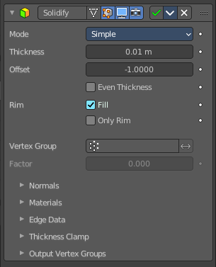
The Solidify modifier adds depth and thickness to the faces of a geometry.
Example. A cube with one face removed.
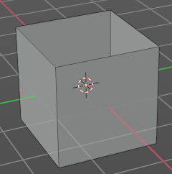
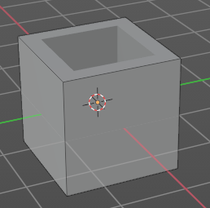

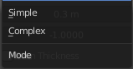
Mode

Simple
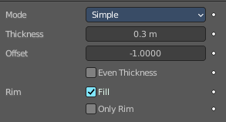
This algorithm simply extrudes the geometry. It does not work on geometry where edges have more than two adjacent faces.
Important! Simple mode will not be able to solidify the boundary between two adjacent faces that does not point into the same direction.

Thickness
The extrude amount.

Offset
A value between (-1 to 1) to locate the solidified output inside or outside the original mesh. The inside and outside is determined by the face normals. Set to 0.0, the solidified output will be centered on the original mesh.

Even Thickness
Maintain the thickness by adjusting for sharp corners.
Note! Solidify thickness is an approximation. The final wall thickness is not guaranteed. The best option to preserve wall thickness is complex mode with constraints thickness mode. But even this is not guaranteed to work perfect in every case.

Rim
Note! Fill and Only Rim only make a difference on Non-manifold objects, since the rims are generated from the borders of the original geometry.

Fill
Fills the gap between the inner and outer edges.

Only Rim
Will not extrude surfaces parallel to the original one, but instead will only add the perpendicular rim.

Complex
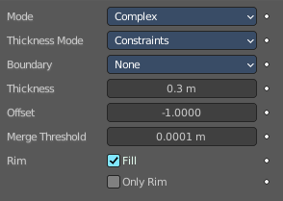
This solidify algorithm can handle every geometric situation to guarantee a manifold output geometry. It is able to solidify shapes like Möbius strips, Klein bottles, architectural wall layouts and many more which the Simple Mode isn’t able to do.
If the special cases are not present it is recommended to choose Simple because the extra logic makes this algorithm much slower.
Note! There are no options for crease in the Modifier tab because crease is handled in a dynamic way. The modifier will transfer the creases of the original mesh in a smart way to the output mesh to work with the Subdivision Surface modifier.

Thickness Mode
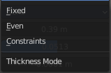
Choose the kind of thickness handling.

Fixed
The new vertices are always in a fixed distance to the old ones.

Even
Adjusts for sharp corners, but may not always work when more than three faces come together.

Constraints
For up to three faces it is always guaranteed to find an optimal solution.

Boundary
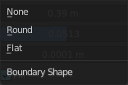
Choose the kind of boundary handling.

None
No boundary fix is applied. Results are stable.

Round
Adjusts the boundary for an opening to face inwards (like a hole in an egg).

Flat
Adjusts the boundary of a planar opening to be a flat (like a cut sphere).

Thickness
The extrude amount.
Important! The modifier thickness is calculated using local vertex coordinates. If the object has a non-uniform scale, the thickness will vary on different sides of the object. To fix this, either Apply or Clear the scale.

Offset
A value between (-1 to 1) to locate the solidified output inside or outside the original mesh. The inside and outside is determined by the face normals. Set to 0.0, the solidified output will be centered on the original mesh.

Merge Threshold
The distance within which degenerated geometry is merged.

Rim
Note! Fill and Only Rim only make a difference on Non-manifold objects, since the rims are generated from the borders of the original geometry.

Fill
Fills the gap between the inner and outer edges.

Only Rim
Will only leave the generated perpendicular rim
Note! Fill and Only Rim only make a difference on Non-manifold objects, since the rims are generated from the borders of the original geometry.

Vertex Group
Only vertices in this group are solidified. Their weights are multiplied by the thickness, so vertices with lower weights will be less thick.

Invert
Reverses the vertex group, so that only vertices which are not in the vertex group are solidified.

Factor
How much the vertex weights are taken into account. You need to have a vertex group assigned to activate this item.
On 0.0, vertices with zero weight will have no thickness at all (creates duplicate vertices).
On 0.5, vertices with zero weight will be half as thick as those with full weight.
On 1.0 , the weights are ignored and the Thickness value is used for every vertex.

Flat Faces
Just in Complex Mode. Use the minimal vertex weight assigned to the vertices of a face to make sure that new faces stays parallel to their original ones. This is slow, so disable it when it is not needed.

Normals

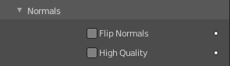
Flip Normals
Reverse the normals of all geometry (both the inner and outer surfaces).

High Quality Normals
Just Simple Mode. Normals are calculated to produce a more even thickness.

Materials

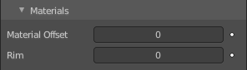
Material Offset
Choose a different material for the new geometry. This is applied as an offset from the original material of the face from which it was solidified.
A value of 0 means it will use the same material.
A value of 1 means it will use the material immediately below the original material.
A value of -2 means the material two positions above the original material will be used.
These values are clamped to the top-most and bottom-most material slots.

Rim
Choose a different material for the rim faces.

Edge Data
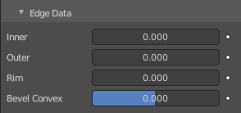
Inner, Outer and Rim are simple mode only.

Inner
Set a crease to the inner edges.

Outer
Set a crease to the outer edges.

Rim
Set a crease to the rim.

Bevel Convex
Edge bevel weight to be added to outside edges.

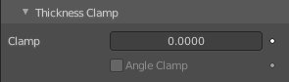
Thickness Clamp

Clamp
A value between (0 to 2) to clamp offsets to avoid self-intersection. The amount is determined by the length of the shortest adjacent edge.

Angle Clamp
If enabled clamping will also consider angles in the geometry, not only lengths. Becomes active when the clamp value is above 0.0.

Output Vertex Groups

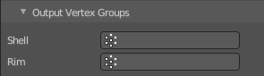
Shell
Vertex group that the generated shell geometry will be weighted to. This allows you to use other modifiers to only affect the shell geometry by using a that modifier’s vertex group influence control.

Rim
Same as Shell Vertex Group, but for the generated rim geometry.

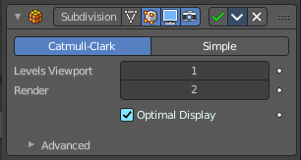
Subdivision Surface modifier
The Subdivision Surface modifier subdivides the faces of the mesh. With Simple it just divides the faces. The Catmull-Clark algorithm allows you to smoothen the result.

Type

Catmull-Clark
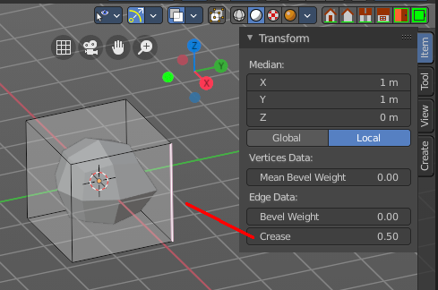
Subdivides and smooths the surfaces.
Note! Catmull-Clark subdivision rounds off edges. And sometimes this is not what you want. There are several solutions that allow you to control the subdivision. You can add a so called support edge or a support loop to keep the edge sharp.
Or you can change the crease of the edges in question. Edge Crease can be adjusted in the Transform panel in the Item tab of the sidebar in the 3D view. You need to be in Edit mode.
Note! Abrupt normal changes in the surface can produce ugly black gouges, even when these flipped normals are not an issue for the shape itself. A quick way to fix this is to use the Recalculate Normals operation in Edit Mode. If you still have some ugly black gouges you can try to manually flip the normals in question.

Simple
Only subdivides the surfaces, without any smoothing.

Levels Viewport
The number of subdivision levels shown in the 3D Viewport.

Render
The number of subdivision levels shown in the final render.

Optimal Display
When rendering the wire frame of this object, the wires of the new subdivided edges will be skipped. Only the edges of the original geometry will be displayed.

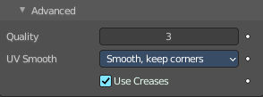
Advanced

Quality
How precisely the vertices are positioned, relatively to their theoretical position of an infinitely subdivided mesh.
Note! This value can have an affect on how accurate Edge Creases can be. Using a higher Quality value will allow for a wider range of crease values to work accurately.

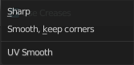
UV Smooth
How to handle UV's during subdivision.

Smooth, keep corners
UV islands are smoothed, but their boundary remain sharp.

Sharp
UV remain unchanged.

Use Creases
Use the Weighted Edge Creases values stored in edges to control the smoothness of the edges.

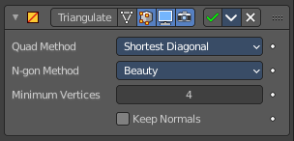
Triangulate Modifier
The Triangulate modifier triangulates all faces in a mesh.

Quad Method
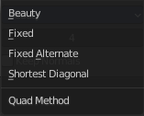
How to triangulate quads.

Beauty
Tries to split the quads in a way that takes the topology into account.

Fixed
Split the quads on their 1st and 3rd vertices.

Fixed Alternate
Split the quads on their 2nd and 4th vertices.

Shortest Diagonal
Split the quads based on the diagonal distance between their vertices.

Polygon Method
How to triangulate N-Gons.

Beauty
Tries to split the N-Gons in a way that takes the topology into account.

Clip
Split the N-Gons by using an ear-clipping algorithm

Minimum Vertices
Minimum number of vertices a face must have to be triangulated. For example, setting this value to 5, will prevent triangulation of Quads and only triangulate N-gons.

Keep Normals
When using custom normals, try to preserve the same shading as before triangulation.

Volume to mesh Modifier
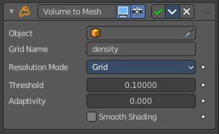
This modifier is the inverse of the Mesh to Volume modifier. It takes an existing volume object and converts one of its grids to a mesh. Only scalar grids (such as the density grid) can be converted.
Tip! To copy and move the generated mesh separately from the volume object, use a collection instance.

Object
The source volume object. Pick the volume object here.

Grid Name
The name of the grid to convert. The grid has to be a scalar grid.

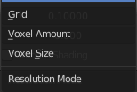
Resolution Mode
How the resolution of the final mesh is controlled.

Grid
This makes the resolution dependent on the resolution of the grid that is converted. Higher resolution grids result in a higher resolution mesh. In many cases, that is the most efficient mode.

Voxel Amount
Specifies the approximate resolution of the final mesh. The voxel size is adapted to the size of the entire volume.

Voxel Size
Use a fixed resolution that does not change when the volume changes.

Threshold
Voxels with a larger value are considered to be inside the mesh and all other voxels outside. The mesh will be generated on the boundary of inside and outside voxels. This is sometimes also called the “iso value”.

Adaptivity
This is similar to decimating the final to reduce resolution where it is not needed.

Smooth Shading
Enables smooth shading on the generated mesh.

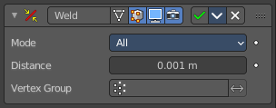
Weld Modifier
The Weld modifier merges vertices within a threshold.

Mode

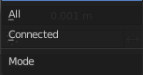
All
Full merge by distance.

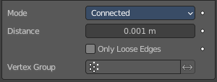
Connected
Just along the edges.

Distance
The maximum distance to merge vertices.

Only Loose Edges
Just with Connected. Welds only loose edges.

Vertex Group
Only merge vertices from this vertex group.

Invert
Inverts the influence of the selected vertex group. Only vertices outside of this vertex group will be merged.

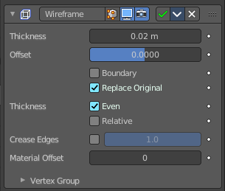
Wireframe Modifier
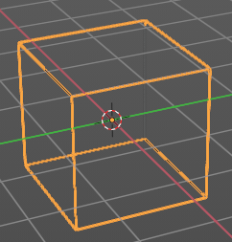
The Wireframe modifier hides the faces of a mesh, and turns the edges into four sided polygon geometry. The result then looks like you would have a wire frame view of the mesh.
The mesh needs to have faces.

Thickness
The depth or size of the wire frames.

Offset
A value between (-1 to 1) to change whether the wire frames. are generated inside or outside of the original mesh. Set to zero, Offset will center the wire frames. around the original edges.

Boundary
Creates wire frames. on mesh island boundaries.

Replace Original
Replace the original mesh by the generated wire frame mesh. If not, the wire frame is generated on top of it.

Thickness
Warning! Wireframe thickness is an approximation. While Even Thickness should yield good results in many cases, skinny faces can cause ugly spikes. In this case you can either reduce the extreme angles in the geometry or disable the Even Thickness option.

Even
Maintain thickness by adjusting for sharp corners. Sometimes improves quality but also increases computation time.

Relative
Determines the edge thickness by the length of the edge. Longer edges will be thicker.

Crease Edges
This option is intended for usage with the Subdivision modifier. Enable this option to crease edges on their junctions and prevent large curved intersections.

Crease Weight
Define how much crease (0 to 1, nothing to full) the junctions should receive.

Material Offset
Uses the chosen material index as the material for the wire frame; this is applied as an offset from the first material.

Vertex Group
Restrict the modifier to only this vertex group, and use its weighting for thickness.

Invert
Inverts the vertex group weights.

Factor
Percentage that the vertex has influence over the final wire frame result.

Smooth Modifier
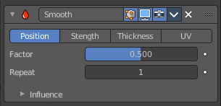
Grease Pencil object only. The Smooth Modifier changes the value of one or more stroke/points properties like: location, strength, thickness or UV texture position trying to maintain similar values that make the line fluid and smoother.

Affect
Combination of stroke/points properties that will be affected by the smooth factor.

Position
Smooth affect the point location.

Strength
Smooth affect the point strength (opacity).

Thickness
Smooth affect the point thickness.

UV
Smooth affect the point UV rotation.

Factor
Strength of the smooth effect.

Repeat
The number of smoothing iterations, equivalent to executing the Smooth tool multiple times. High values can reduce the animation performance (FPS).

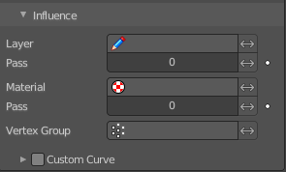
Influence

Layer
Restricts the effect only to one layer or to any layers that share the same pass index. Click to pick the layer that you want to use.

Invert
Inverts the influence.

Pass
The layer pass index.

Invert
Inverts the influence.

Material
Restricts the effect only to material that share the same material or pass index. Click to pick the material that you want to use.

Invert
Inverts the influence.

Pass
The material pass index.

Invert
Inverts the influence.

Vertex Group
Limit the influence to a vertex group.

Invert
Inverts the influence.

Custom Curve
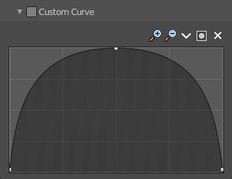
Use a custom curve to define the noise along the strokes.

Navigation elements
The navigation elements at the top are described from left to right.

Zoom in and out
The two buttons with the magnifying glass at it zooms in and out in the curve window.

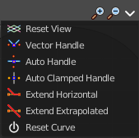
Tools
Tools is a menu where you can find some curve related tools.

Reset View
Resets the curve windows zoom.

Vector Handle
Set handle type to Vector.

Auto Handle
Set handle type to Auto.

Auto Clamped Handle
Set handle type to Auto Clamped.

Extend Horizontal
Extend the curve points horizontal before the first curve point and after the last curve point.

Extend Vertical
Extend the curve points vertical before the first curve point and after the last curve point.

Reset Curve
Resets the curve to the initial shape.

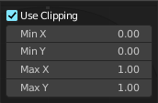
Use Clipping
Clipping options. Set up clipping for the stroke.

Delete Points
Deletes selected curve points.

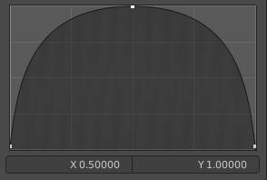
Curve window
Tweak and adjust the falloff curve by clicking at a curve point and dragging it around.
Double click adds a new point.
Holding down ctrl activates temporary snapping.
Holding down shift enables slower movement, which allows more accurate setting.

X / Y
The position of the currently selected curve point.

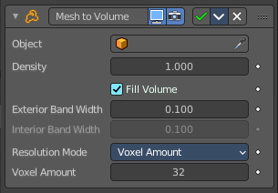
Mesh to Volume
You need a volume object.
The Mesh to Volume modifier uses a mesh to create a new volume grid. All previously existing volume grids on the volume object are discarded. So this modifier is usually added to an empty volume object. The new volume grid is called “density”.
Tip! To copy and move the generated volume separately from the mesh object, use a collection instance.

Object
The mesh object to use for the volume generation. Pick a mesh object here.

Density
Makes the generated volume appear denser or less dense when rendering.

Fill Volume
The entire enclosed volume or otherwise only the voxels close to the surface will get a density greater than zero. This setting is only used when the mesh object is Manifold.

Exterior Band Width
The maximum distance of the included voxels to the surface on the outside of the mesh.

Interior Band Width
The maximum distance of the included voxels to the surface on the inside of the mesh. Activating Fill Volume is similar to increasing the interior band width to a high number.

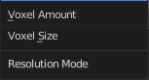
Resolution Mode
Mode for how the voxel size is specified.

Voxel Amount
This allows setting an approximate number of voxels that will be used to represent mesh along its diagonal. When the dimensions of the mesh changes, the voxel size will change as well. For final rendering of animations, it’s better to specify the voxel size explicitly to avoid artifacts.

Voxel Size
This allows setting the exact voxel size that will be used. This is idea for rendering when the voxel size should not change between frames.

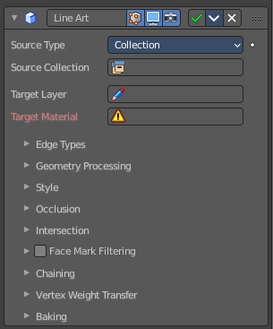
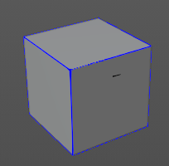
Line Art Modifier
The line art modifier allows you to use a grease pencil object and its colors and materials to for example color the edges of a mesh. It is in the result similar to the line art renderer. But you use grease pencil strokes instead. The modifier gets applied to the grease pencil object.
Workflow: Add mesh, add grease pencil object. Add the modifier. When you choose Collection as the source type, then all objects in this collection are affected. The add the target layer and add the target material.

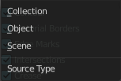
Source Type
Define the target object(s) that you want to affect.

Collection
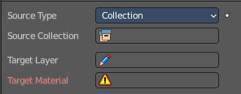
The whole collection is affected.

Source Collection
Choose the collection that you want to affect.

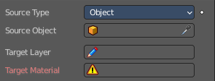
Object
A specific object is affected.

Source Collection
Choose the object that you want to affect.

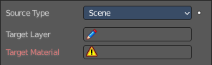
Scene
The whole active scene is affected.

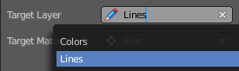
Target Layer
Choose the source grease pencil layer.

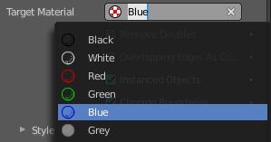
Target Material
Choose the source grease pencil material.

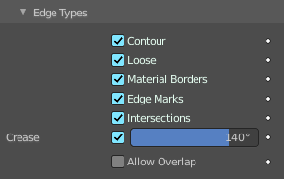
Edge Types Subpanel
What kind of edge types should be affected.

Crease Threshold
Angles smaller than this angle will be treaten as creases.

Allow Overlap
Allow an edge to have multiple overlapping types

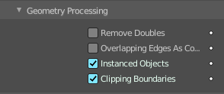
Geometry Processing Subpanel

Remove Doubles
Remove double geometry before generating strokes

Overlapping Edges as Contour
Allow edges in the same location to show properly.

Instanced Objects
Support particle objects and face / vertex instances to show in line art.

Clipping Boundaries
Allow lines generated by the near/far clipping plane to be shown.

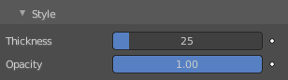
Style subpanel

Thickness
The thickness of the grease pencil stroke.

Opacity
The opacity of the grease pencil stroke.

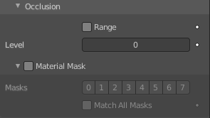
Occlusion subpanel

Range

Level
With Range off. Minimum nunber of occlusions for the generated strokes.

Level Start / Level End
With Range on. Minimum and maximum number of occlusions for the generated strokes.

Material Masks
Use material masks to filter out occluded strokes.

Masks
The mask to use. The masks uses a bit value.

Match all masks
Require to match all transparency masks.

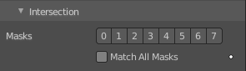
Intersections subpanel
Use material masks to filter out intersections.

Masks
The mask to use. The masks uses a bit value.

Match all masks
Require to match all transparency masks.

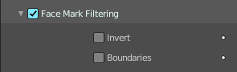
Face Mask Filtering subpanel
Filter feature lines using freestyle face masks.

Invert
Invert the face mask filtering.

Boundaries
Filter feature lines based on face mark boundaries.

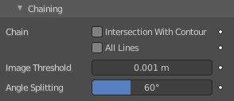
Chaining Subpanel

Chain

Intersection With Contour
Treat intersection and contour lines as the same type so that they can be chained together.

All Lines
Treat all lines as the same line so that they can be chained together.

Image Threshold
Segments with an image distance smaller than this value will be chained together.

Angle Splitting
The angle in screen space below which a stroke is split into two strokes.

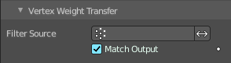
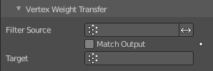
Vertex Weight Transfer
Allows you to limit the line art to vertex groups. You can't choose the vertex group from the filter source edit box. You need to type it in by hand. And watch the order of the vertex groups. Everything below the chosen vertex group is ignored.

Filter Source
The lowest vertex group that gets influenced. When left empty, then all vertex groups are affected.

Match Output
Match output vertex group by name instead of index.

Target
Vertex Group for the stroke.

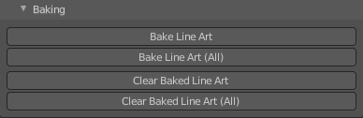
Baking
Bake the grease pencil geometry.

Bake Line Art
Bake the line art for the current grease pencil object.

Bake Line Art ( All )
Bake the line art for all grease pencil objects that has a line art modifier applied.

Clear Baked Line Art
Clear the baked line art for the current grease pencil object.

Clear Baked Line Art ( All )
Clear the baked line art for all grease pencil objects that has a line art modifier applied.

Vertex Weight Modifier
Allows to auto generate weights. The grease pencil stroke needs to have a vertex group assigned.
Note that at this point it is not to figure out how this modifier is meant to work. I know what it should do, but it does nothing. So just guessing here, and listing the operators.

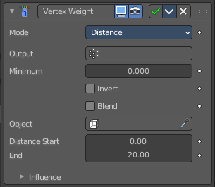
Mode

Distance
Calculates the weight by the distance to Target object. The distance calculated is normalized to get valid weights between 0 and 1.0.

Output
Pick the vertex group for the output. Note that the stroke needs to have a vertex group assigned.

Minimum
Minimum Value for Vertex Weight.

Invert
Invert the weight values.

Blend
Blend the result with existing weights in the output vertex group.

Object
The target object to calculate the distance.

Distance Start
The minimum distance value.

Distance End
The maximum distance value.

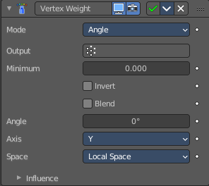
Angle
Calculates the weight by the angle of thte stroke rleative to object or world orientation. For example, if the value is 90, the maximum weights will be for vertical lines and minimum for horizontal lines.

Output
Pick the vertex group for the output. Note that the stroke needs to have a vertex group assigned.

Minimum
Minimum Value for Vertex Weight.

Invert
Invert the weight values.

Blend
Blend the result with existing weights in the output vertex group.

Angle
The angle to calculate the weights from.

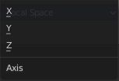
Axis
The axis to calculate.

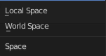
Space
If the calculation happens in local or global space.

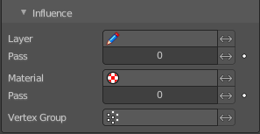
Influence subpanel
Allows you to set the influence for several further aspects.

Layer
Restricts the effect only to one layer or to any layers that share the same pass index. Click to pick the layer that you want to use.

Invert
Inverts the influence.

Pass
The layer pass index.

Invert
Inverts the influence.

Material
Restricts the effect only to material that share the same material or pass index. Click to pick the material that you want to use.

Invert
Inverts the influence.

Pass
The material pass index.

Invert
Inverts the influence.

Vertex Group
Limit the influence to a vertex group.

Invert
Inverts the influence.

